Volleyball Name: _________________________
Lifetime Sports & Team Sports
Date: ____________ Period _____

- History:

Inventor of volleyball: ___________________________________

Year & location volleyball was invented: _______________________

Two characteristics sports to create volleyball: _____________________________

- First set of rules:

Name 3 sets of old rules that were used when it first originated:

- ____________________________________________________

- _____________________________________________________________

- _____________________________________________________________

- Today’s game:

Name the common set up for an offensive team that is used in today’s game:

- ______________________

- __________________________

- __________________________

- Serving:

The server must serve from _________________ the restraining line (end line) until

after contact.

Two ways you can serve the ball:

- ________________________ & 2. _____________________________

The ball must be clearly ____________________ to opponents before serve.

Can the serve graze the net and drop to the other side for a point? YES or NO

How is the first game serve determined? ___________________________________

After each game, the loser will serve to start the game.

The serve must be returned by a ______________________ no setting or attacking a serve.

- Scoring:

- _________________ scoring will be use

- There will be a ________________ scored on ___________________________

- ________________ will score on a defense miss or out of bounds hit.

________________ will score on an offensive miss, out of bounds, or serve hits the net.

- Games will be played to _____________ points.

- Must win by _________ points

- Rotation:

How to rotate:

- ____________________________________________________

- _____________________________________________________________

c. ______________________________________________________________

- Playing the Game (Volley):

- Maximum # of hits per side __________________

- Player may or may not hit the ball twice in succession? __________________

- Can the ball be played off the net during a volley or serve? YES or NO

- If the ball touches the boundary line it is good? YES or NO

- If two or more players contact the ball simultaneously, it is considered two separate hits and can participate in the next play? YES or NO

- Can a player on defense block or attack (spike) a serve? YES or NO

- Only the _________________ line players can switch position after the serve only.

- Violations: (8 ways you would get called for a violation)

- _____________________________________________________________

- _____________________________________________________________

- _____________________________________________________________

- _____________________________________________________________

- Reaching over the net, except under these conditions:

  - _________________________________________________________

  - _________________________________________________________

- _____________________________________________________________

- _____________________________________________________________

- _____________________________________________________________
- Terms:

Ace: _______________________________________________________

Dig: _______________________________________________________

Kill: _______________________________________________________

Roof: ______________________________________________________

Sideout: ____________________________________________________

Stuff: ______________________________________________________

- Court Size: Know size of court length & width

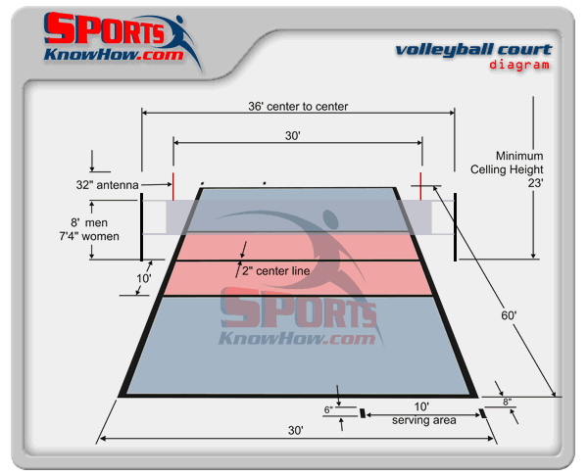

- Height of Net? Men:__________ Women: _____________

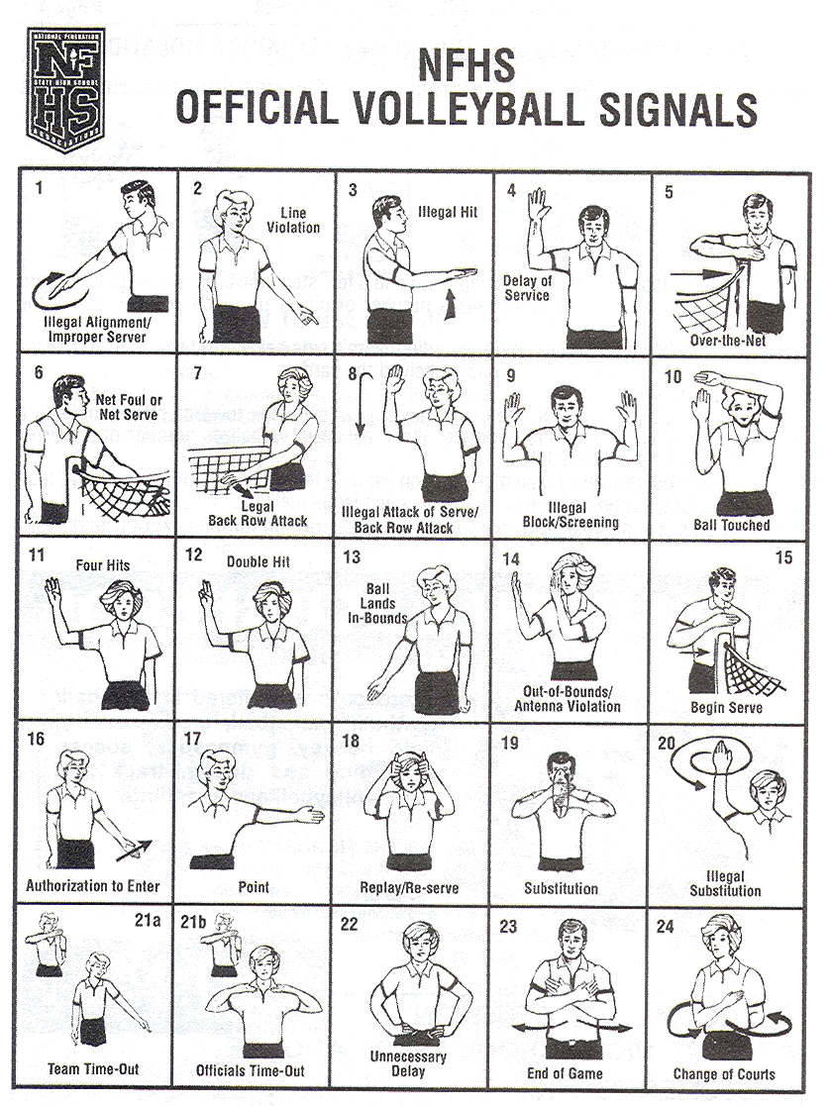
- Referee Signals:

- Today verses the Past:

How is volleyball a popular sport today?

________________________________________________________

________________________________________________________

________________________________________________________

Enjoy the game of volleyball!!!!!

