BPE Name __________________________________
Circulatory System
Coach Soley/Wishon/Dodd/Hubinger/Keller Period _______ Date _______________

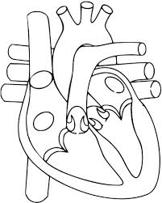
Fill in the spaces below with the correct label and use arrows for the blood pathway.

Mitral Valve Tricuspid valve Aortic valve
Pulmonary vein Left ventricle Left atrium
Septum Pulmonary arteries Pulmonary valve
Inferior vena cava Superior vena cava Aorta
Right ventricle Right Atrium

Use blue arrows for deoxygenated blood and red arrows for oxygenated blood.

